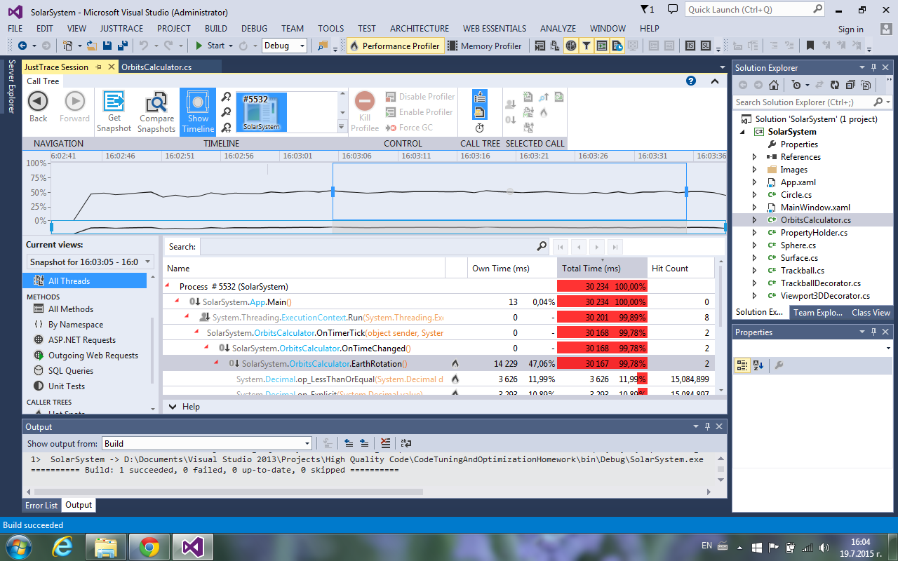

OrbitsCalculator.EarthRotation() 🡪 line 96 and line 98

ERROR 🡪 Too small step update

